Impact of PCA on Supervised and Unsupervised Learning: Gender Classification in Current Population Survey Data
Table of Contents
- Introduction
- Data Description
- Analysis
  - 3.1 Feature Reduction with PCA
  - 3.2 Supervised Learning: KNN Classification
  - 3.3 Unsupervised Learning: KMeans Clustering
- Results
  - 4.1 Supervised Learning Results
  - 4.2 Unsupervised Learning Results
  - 4.3 Comparative Analysis
- Additional Approaches
- Conclusions

1. Introduction
Imagine trying to find a pattern in a dataset with hundreds of features - it's like looking for a specific person in a crowded stadium. This study examines how we can simplify this task by reducing the number of features we need to consider, while still maintaining the important information.
We're using a technique called Principal Component Analysis (PCA) on the Current Population Survey dataset to see if it helps two different types of machine learning approaches:
- Supervised learning - where we teach the computer to predict gender based on examples
- Unsupervised learning - where the computer tries to find natural groupings without being told what to look for
Working with datasets that have many features (like our 188 features) creates several problems:
- Calculations take much longer
- Too many features can confuse the algorithm (known as the "curse of dimensionality")
- Models might memorize the training data instead of learning general patterns
PCA helps by combining the original features into a smaller set of new features (called principal components) that capture most of the important variations in the data. Think of it like compressing a photo - you reduce the file size while keeping the important details visible.
In this study, we'll look at how PCA affects:
- The accuracy of gender predictions in supervised learning
- How well the computer can naturally group people by gender in unsupervised learning
- How much faster both approaches run after using PCA
2. Data Description
For this project, we used the Current Population Survey (CPS), which is a large survey of U.S. households conducted monthly by the government. This survey collects information about employment, demographics, income, and many other characteristics of the American population.
Our cleaned dataset includes:
- 289,405 individuals (rows in our dataset)
- 188 different characteristics about each person (columns/features)
- Target Variable: Gender (male or female)
These characteristics include information like:
- Age, education level, and marital status
- Income and poverty status
- Employment information (occupation, hours worked, etc.)
- Geographic location
- Race and ethnicity
- Household information
Before we could use this data, we had to:
- Clean it by removing rows with too many missing values
- Convert text categories into numbers (for example, changing "Male"/"Female" to 0/1)
- Scale all the values to be in similar ranges so features with larger numbers wouldn't dominate the analysis
The large size of this dataset (over 100,000 individuals and more than 100 features) makes it ideal for testing how well PCA works on complex real-world data.
3. Analysis
3.1 Feature Reduction with PCA
What is PCA and Why Use It?
Principal Component Analysis (PCA) is like finding the most important angles to photograph a complex object. Instead of taking hundreds of photos from every possible angle, you identify just a few key angles that show most of the object's important features.
In our case, we reduced the original 187 features down to just 35 "principal components" - a reduction of 81.28%. These 35 components still capture 79.89% of all the information in the original data.
How PCA Works (In Simple Terms):
- Standardize the data: Make sure all features are on the same scale
- Find directions of maximum variation: Identify where the data varies the most
- Rank these directions: Order them from most important (capturing the most variation) to least
- Keep only the top components: We kept the top 35 components
- Transform the data: Convert the original data into this new, smaller set of features
The graph below shows how much information each component captures. The blue bars show individual components, while the red line shows the cumulative information captured. The green line marks the 95% threshold that's often used as a target.
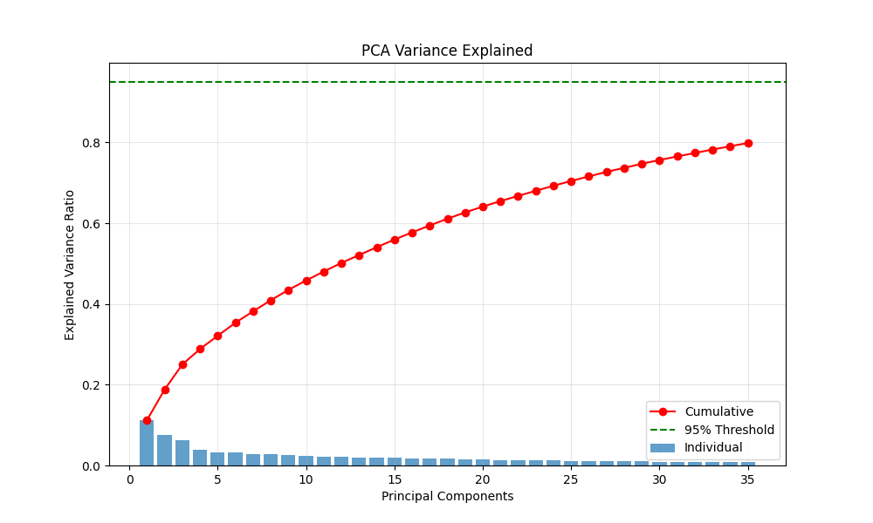
Even though we didn't reach the 95% threshold with 35 components, capturing about 80% of the information while reducing dimensions by over 80% represents an excellent trade-off between simplification and information preservation.
3.2 Supervised Learning: KNN Classification
What is KNN and How Does It Work?
K-Nearest Neighbors (KNN) is a simple but powerful classification method. It works like asking your 12 closest neighbors to vote on a question, then going with the majority opinion.
In technical terms:
- For each person in our test set, the algorithm finds the 12 most similar people in the training data
- It looks at the gender of these 12 similar people
- It predicts the gender that appears most frequently among these neighbors
We chose KNN with k=12 because it's:
- Easy to understand
- Effective for classification tasks
- Doesn't make assumptions about the data's structure
We created two KNN models:
- KNN without PCA: Using all 187 original features
- KNN with PCA: Using only the 35 principal components
To ensure a fair comparison, we used the same train-test split (80% training, 20% testing) for both models and evaluated them using the same metrics.
3.3 Unsupervised Learning: KMeans Clustering
What is KMeans and How Does It Work?
KMeans clustering tries to find natural groupings in data without being told what to look for. Think of it like sorting a pile of mixed fruits - you might naturally group them by type even without labels.
In our study:
- We specified k=2 clusters (since we're looking at a binary gender classification)
- The algorithm randomly places 2 "center points" in the data
- It assigns each person to the nearest center
- It recalculates each center based on the average of all points assigned to it
- It repeats steps 3-4 until the centers stop moving significantly
We compared two clustering approaches:
- KMeans without PCA: Using all 187 original features
- KMeans with PCA: Using only the 35 principal components
For handling this large dataset efficiently, we used MiniBatchKMeans, which works with smaller random samples of data at a time.
After clustering, we compared the resulting groups with the actual gender labels to see how well the algorithm discovered gender patterns naturally, without being explicitly trained to do so.
4. Results
4.1 Supervised Learning Results
Our supervised learning results reveal something fascinating - PCA maintained nearly identical prediction accuracy while making the model run much faster:
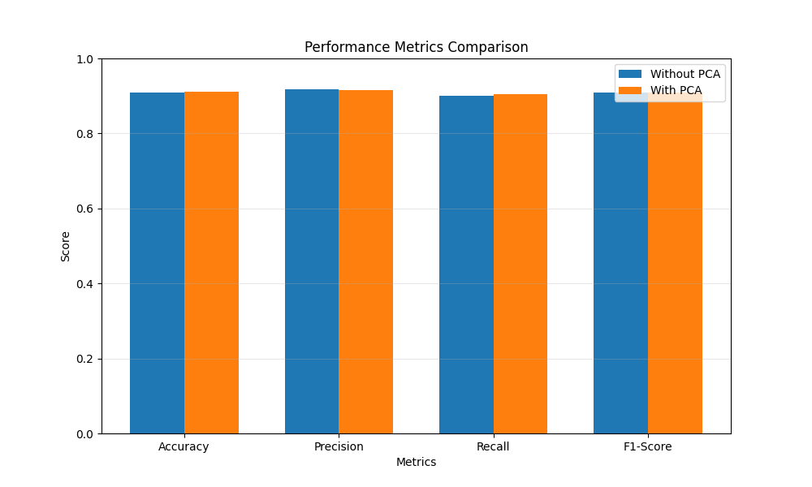

Figure 1: This bar chart compares how well KNN performed with and without PCA. Notice how the blue bars (without PCA) and orange bars (with PCA) are almost exactly the same height for all performance metrics.
Table 1: KNN Classification Performance Metrics
Metric | Without PCA | With PCA | Difference
Accuracy | 0.9107 | 0.9107 | 0.0000
Precision | 0.9137 | 0.9139 | +0.0002
Recall | 0.9048 | 0.9046 | -0.0002
F1-Score | 0.9092 | 0.9092 | 0.0000
Training Time (sec) | 10.2468 | 1.7654 | -8.4814
Inference Time (sec) | 9.3574 | 0.6028 | -8.7546
What These Results Mean:
- No Loss in Prediction Quality: The accuracy stayed exactly the same at 91.07%, and other metrics (precision, recall, F1-score) changed by less than 0.02%.
- Massive Speed Improvement:
  - Training time dropped from 10.2 seconds to 1.8 seconds (82.8% faster)
  - Prediction time dropped from 9.4 seconds to 0.6 seconds (93.6% faster)
Confusion Matrices:
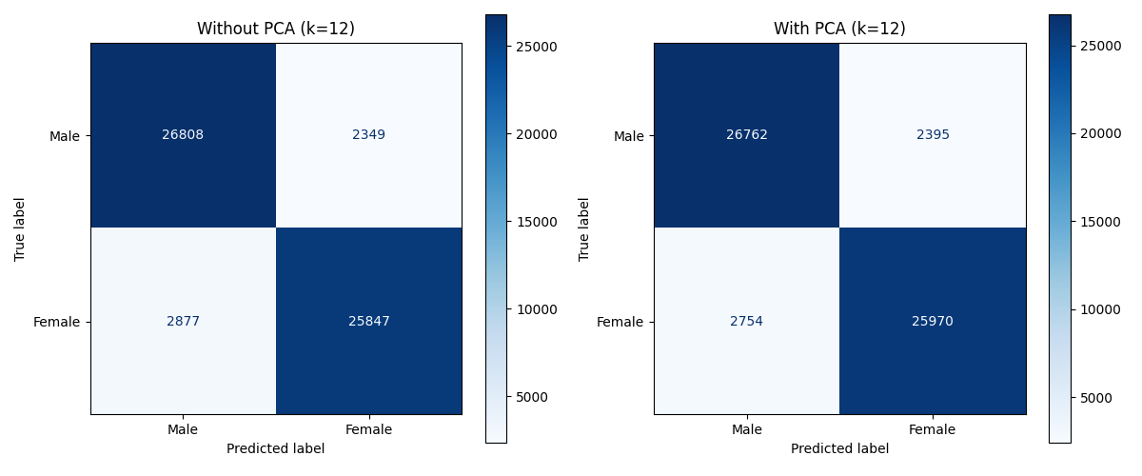
Figure 2: These confusion matrices show how many individuals were classified correctly and incorrectly. The left matrix shows results without PCA, and the right shows results with PCA.
Reading the Confusion Matrices:
The numbers in each box show:
- Top-left: True males classified as males (~26,800)
- Top-right: True males misclassified as females (~2,350)
- Bottom-left: True females misclassified as males (~2,800)
- Bottom-right: True females classified as females (~25,900)
Both matrices look almost identical, confirming that PCA maintained the same prediction patterns while dramatically improving speed.
4.2 Unsupervised Learning Results
Unlike with supervised learning, PCA made a dramatic difference in how well our unsupervised KMeans algorithm performed - improving both clustering quality and speed:
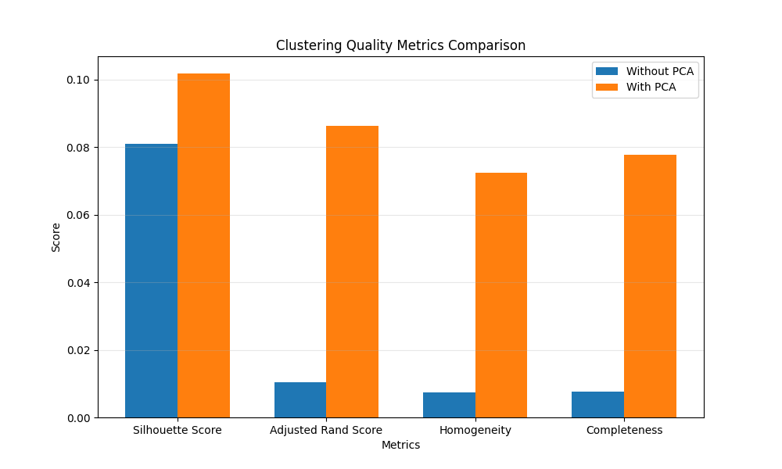
Figure 3: This bar chart shows the quality metrics for KMeans clustering. Notice how the orange bars (with PCA) are much taller than the blue bars (without PCA) for all metrics, indicating substantial improvement.
Table 2: KMeans Clustering Performance Metrics
Metric | Without PCA | With PCA | Difference | % Improvement
Silhouette Score | 0.0809 | 0.1018 | +0.0209 | +26%
Adjusted Rand Index | 0.0105 | 0.0864 | +0.0759 | +722%
Homogeneity | 0.0074 | 0.0726 | +0.0652 | +880%
Completeness | 0.0074 | 0.0777 | +0.0703 | +949%
Clustering Time (s) | 87.4563 | 5.6742 | -81.7821 | -93.5%
What These Metrics Mean:
- Silhouette Score: Measures how well-separated the clusters are (higher is better)
- Adjusted Rand Index (ARI): Measures how well the clusters match the actual gender labels
- Homogeneity: Measures if each cluster contains only members of a single class
- Completeness: Measures if all members of a given class are in the same cluster
Cluster Visualizations:
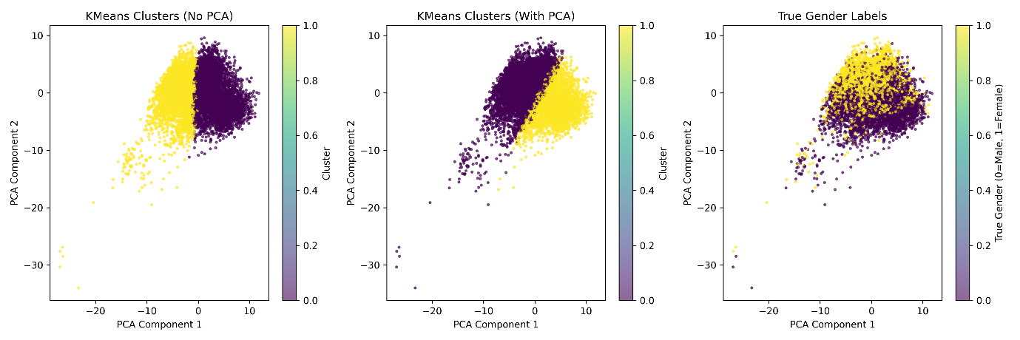
Figure 4: These three plots show how the data points are grouped in 2D space:
- Left: Clusters formed without PCA
- Middle: Clusters formed with PCA
- Right: Actual gender distribution (for comparison)
Looking at these visualizations, we can see that:
- The clustering with PCA (middle) creates cleaner separation between groups
- The clustering patterns are more aligned with the actual gender distribution (right) when using PCA
- Without PCA (left), the clusters don't align as well with gender
Cluster Distribution Heatmaps:
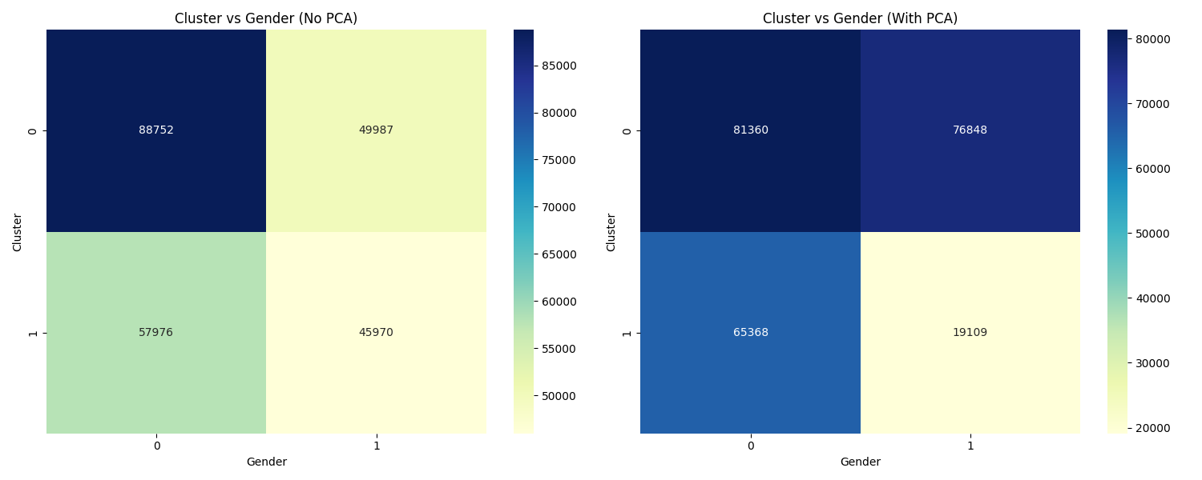
Figure 5: These heatmaps show how males (0) and females (1) are distributed across the two clusters:
Without PCA (left):
- Cluster 0 has 88,752 males and 49,987 females
- Cluster 1 has 57,976 males and 45,970 females
- The clusters don't separate genders very effectively
With PCA (right):
- Cluster 0 has 81,360 males and 76,848 females
- Cluster 1 has 65,368 males and only 19,109 females
- Cluster 1 has a much stronger correlation with being male
This dramatic improvement shows that PCA helped the algorithm find more meaningful patterns related to gender.
4.3 Comparative Analysis
Let's compare how PCA affected both supervised (KNN) and unsupervised (KMeans) approaches:
Table 3: Side-by-Side Comparison of Approaches With and Without PCA
Aspect | Supervised Learning | Unsupervised Learning
Performance without PCA | Accuracy: 0.9107 | ARI: 0.0105
Performance with PCA | Accuracy: 0.9107 | ARI: 0.0864
Performance change | No change | +722% improvement
Time improvement with PCA | 93.56% | 93.52%
Dimension reduction | 81.28% | 81.28%
Variance explained | 79.89% | 79.89%
Key Insights from This Comparison:
- Different Impact on Each Approach
  - For Supervised Learning (KNN): PCA was like upgrading from a regular car to an electric car that goes just as fast but uses much less energy. The performance stayed the same, but it ran much more efficiently.
  - For Unsupervised Learning (KMeans): PCA was like giving someone glasses who needed them badly. Not only did it run faster, but it actually "saw" the patterns much more clearly, with a 7-fold improvement in how well the clusters matched gender.
- Same Computational Benefits
  - Both approaches became about 93.5% faster when using PCA
  - This consistent speed improvement shows that dimension reduction benefits any algorithm working with high-dimensional data
- The Power of Labels
  - Supervised learning (which uses gender labels during training) performed much better overall than unsupervised learning (which doesn't use labels)
  - However, PCA helped narrow this gap significantly by helping the unsupervised approach find more meaningful patterns
- Noise Reduction Effect
  - The fact that unsupervised learning improved so much with PCA suggests that the original data contained a lot of "noise" (irrelevant information) that confused the clustering algorithm
  - PCA effectively filtered out this noise, making the important gender-related patterns more visible
5. Additional Approaches
While our study showed interesting results with KNN and KMeans, there are many other methods we could try that might work even better. Here are some alternatives worth exploring:
- Other Ways to Predict Gender (Supervised Approaches):
  - Support Vector Machines (SVM): These draw boundaries between different groups in clever ways. They might find better separation between genders.
  - Random Forests: These combine many decision trees (like playing "20 Questions" multiple times) and take a vote on the final answer. They often perform very well on complex data.
  - Neural Networks: These are inspired by how brain cells work and can learn very complex patterns. They might capture subtle gender-related patterns that simpler methods miss.
- Other Ways to Find Natural Groups (Unsupervised Approaches):
  - DBSCAN: This finds clusters based on density rather than circles. It's good at finding irregular-shaped clusters and identifying outliers.
  - Hierarchical Clustering: This builds a tree of clusters, from individual points up to larger groups. It might reveal interesting subgroups within gender categories.
  - Gaussian Mixture Models: These assume data comes from several overlapping distributions. They're more flexible than KMeans and give probability scores instead of hard assignments.
- Other Ways to Reduce Dimensions:
  - t-SNE: This is especially good for visualization, as it preserves local relationships between points.
  - UMAP: A newer technique that preserves both local and global structure better than t-SNE.
  - Feature Selection: Instead of creating new combined features (like PCA), we could just pick the most important original features. This would make results more interpretable.
- Fine-Tuning the Algorithms:
  - Grid Search: Systematically trying different values for k in KNN (instead of just k=12)
  - Different Distance Measures: Using Manhattan distance or other metrics instead of Euclidean distance
  - Ensemble Methods: Combining multiple models to get better predictions
These alternative approaches could potentially improve our results even further, especially if we tailor them to the specific characteristics of demographic data.
6. Conclusions
Our study shows that reducing dimensions with PCA has powerful effects on machine learning with demographic data. Here are the key lessons learned:
1. PCA Gives Speed Without Sacrificing Accuracy
We reduced the number of features by 81% (from 187 to 35) while keeping 80% of the information. For supervised learning, this maintained the same 91% prediction accuracy while making the model run 93% faster. This confirms what data scientists often say: "Most real-world datasets have much fewer important dimensions than you might think."
2. PCA Makes Unsupervised Learning See Clearer Patterns
The most dramatic finding was how much PCA improved clustering:
- The Adjusted Rand Index (how well clusters match actual genders) improved by 722%
- Homogeneity and completeness scores increased by over 800%
This is like cleaning a dirty window - suddenly patterns that were hard to see become much clearer.
3. Different Learning Methods React Differently to PCA
The contrast between supervised and unsupervised results reveals something interesting:
- Supervised learning (KNN) worked well even with "noisy" data because it had gender labels to guide it
- Unsupervised learning (KMeans) struggled with noisy data, but improved dramatically when PCA filtered out the noise
This highlights how labels help algorithms focus on what's important, while unlabeled approaches need cleaner data to find meaningful patterns.
4. Speed Improvements Are Universal
Both approaches got about 93.5% faster with PCA. This consistent speed boost applies regardless of what learning method you use - a major advantage when working with big data.
5. Practical Takeaways for Working with Demographic Data
Based on these findings, we recommend:
- For supervised learning: Use PCA mainly to make your models run faster
- For unsupervised learning: Definitely use PCA - it both improves results and speeds up processing
- For both approaches: Start with more components than you think you need, then reduce if necessary
The broader lesson is that dimension reduction should be a standard first step when working with high-dimensional data, especially for unsupervised learning approaches. It's like having a good pair of glasses - it helps algorithms see what really matters in complex, messy data.

